**IBM ASSIGNMENT – 2**

**Python Programming**

|  |  |
| --- | --- |
| Assignment Date | 23 September 2022 |
| Student Name | Monish R |
| Student Roll Number | 710019106028 |

**Build a python code, Assume u get temperature and humidity values (generated with random function to a variable) and write a condition to continuously detect alarm in case of high temperature.**

**CODE:**

import random

def temperature():

value=random.randint(15,100)

return value

t=temperature()

t=int(input("Enter the temperature value"))

if(t>60):

print("HIGH temperature detected")

print("Buzzer ON")

elif(t==60):

print("Temperature exceeds limit")

else:

print("Temperature is NORMAL")

def humidity():

range=random.randint(40,100)

return range

h=humidity()

h=int(input("Enter the humidity range"))

if(h>70):

print("High humidity range detected")

print("Buzzer ON")

elif(h==70):

print("Humidity exceeds range")

else:

print("Humidity is NORMAL")

**PROGRAM :**

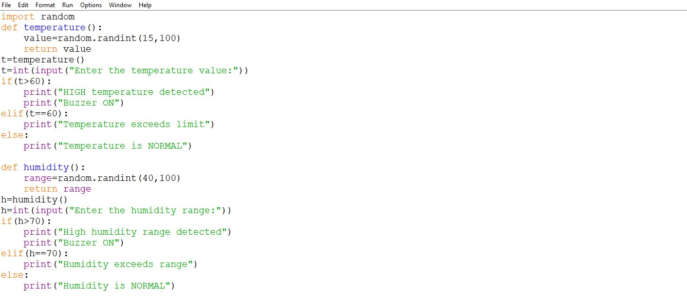

**OUTPUT:**

